University of Washington SNM Lesion Phantom Report

Robert Doot and Paul Kinahan, March 28, 2007
Edited: Hannah Mary Thomas T January 23, 2015
Contact kinahan@u.washington.edu

1. Known or estimated phantom parameters

The phantom was manufactured by Sanders Medical(www.sandersmedical.com) in December of 2006. The phantom was based on a NEMA NU-2 IQ phantom (manufactured by Data Spectrum, Durham NC), but with the central 5 cm diameter 'lung' cylinder of the IQ phantom removed. In addition the two larger fillable spheres were changed to hot spheres, as opposed to cold spheres as in the NEMA NU-2 specifications. Nominal target/background ratio was 4:1 with the initial background activity level set to be equivalent to 15 mCi in a 70 Kg patient, With the 271 day half-life of Ge-68 after 6 months the activity will be about 9.5 mCi. After a year it was 6 mCi.

During initial imaging it was noticed that there were air gaps in the phantom, likely caused by shrinkage of the epoxy material during the exothermic curing of the material. CT and PET images of the phantom are shown in Fig. 1. Air gaps (white regions) in the main chamber and stems, and to some extent in the spheres themselves, are evident on the CT images. It was decided that while the air gaps in the spheres prevented effective calculation of the true resolution losses, the phantom could still be used to perform relative comparisons between scanners. It should be noted that even if the spheres were completely filled, the sphere wall thickness would impact recovery coefficient calculations for the smaller spheres.

Two other potentially detrimental factors were noticed: the phantom is slightly warped, by one or two mm, and will not lie flat. In the larger sphere the wall material has a significant change in density where it attaches to its stem. In discussions with Sanders Medical it was felt that this was likely due to the sphere manufacturing process. This would pose a challenge for any segmentation process that attempts to delineate the sphere volume.

Finally, there were two aliquots made of the background and sphere material in small plastic tubes intended for independent measurement of true background and sphere activity. Unfortunately the volume of the material (~1cc) was too large (and actual volume unknown) for measurement in a well counter and too small for accurate measurement in a dose calibrator.

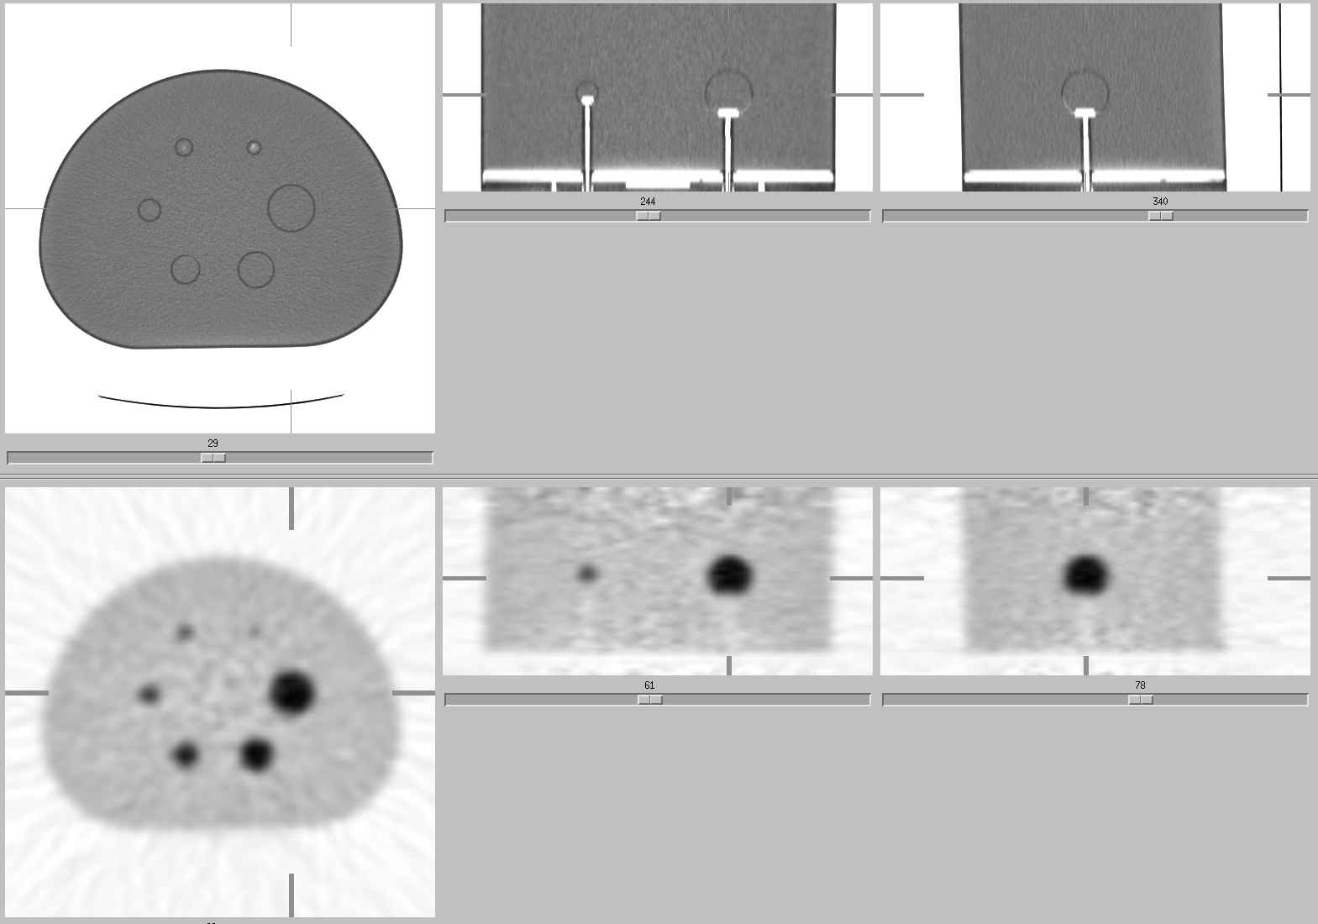

Figure 1: Axial and coronal sections through CT and PET images of the SNM Lesion Phantom. Air gaps (white regions) in the main chamber and stems, and to some extent in the spheres themselves, are evident on the CT images. This was not the final image used for analysis due to the slight pitch evident in the sagittal sections (third column).

Table 1: Phantom parameters
Base model: | Data Spectrum NEMA NU-2 IQ phantom
Nominal interior volume (empty): | 9.7 L
Interior length of phantom: | 180 mm
Sphere diameters (ID) (mm): | 0, 13, 17, 22, 28, 37
Radioactive material: | Ge68/Ga68 with 271 day half life for Ge68
Branching ratio for Ga68: | 89%
Assay (mCi or MBq): | 4.5 mCi (168 MBq)
Date of assay: | 22-Jan-07
Background concentration | 0.44 uCi/ml (as reported by Sanders)
Hot spheres concentration | 1.75 uCi/ml (as reported by Sanders)
True T/B ratio | 4.00 (as reported by Sanders)
Weight of filled phantom | 29.4 lbs (13.3 kg)
Weight of equivalent empty phantom | 5.4 lbs (2.4 kg)
Net weight of epoxy/Ge68 matrix | 24.0 lbs (10.9 kg)
Approximate volume of epoxy/Ge68 matrix | 10.9 kg / (1.058 g/cc) = 10.3 L
Mass attenuation coefficient of active resin@511 keV | 0.103 (mm²/g)
CT numbers of active resin @ 120 kVp | 60 ± 6 HU

2. SNM lesion phantom exam parameters

During scan setup the phantom was registered in the scanner registration software with the following (unlisted parameters were left blank):

Table 2: SNM lesion phantom exam parameters
Last name: | SNMphantom
Weight: | 24 lbs (= 10.9 kg)
Height:
Pre-injection assay (mCi or MBq): | 168 MBq
Date and Time of pre-injection assay: | 01/22/2007 @ 12:00 pm
Date and Time of Injection: | 01/27/2007 @ 12:00 pm
Post-injection assay (mCi or MBq): | 0.0
Date and Time of post-injection assay: | 01/27/2007 @ 12:01 pm

3. Phantom Positioning

The phantom was carefully positioned in the center of the transverse scan field of view (FOV) to approximately ±2 mm using alignment lasers and trial projection views and CT scans. This also required careful adjustment of the three angles of rotation of the scanner, again using alignment lasers and trial projection views and CT scans. From the CT scans the alignment was verified by checking that the maximum diameter of the spheres occurred in the same transaxial CT image.

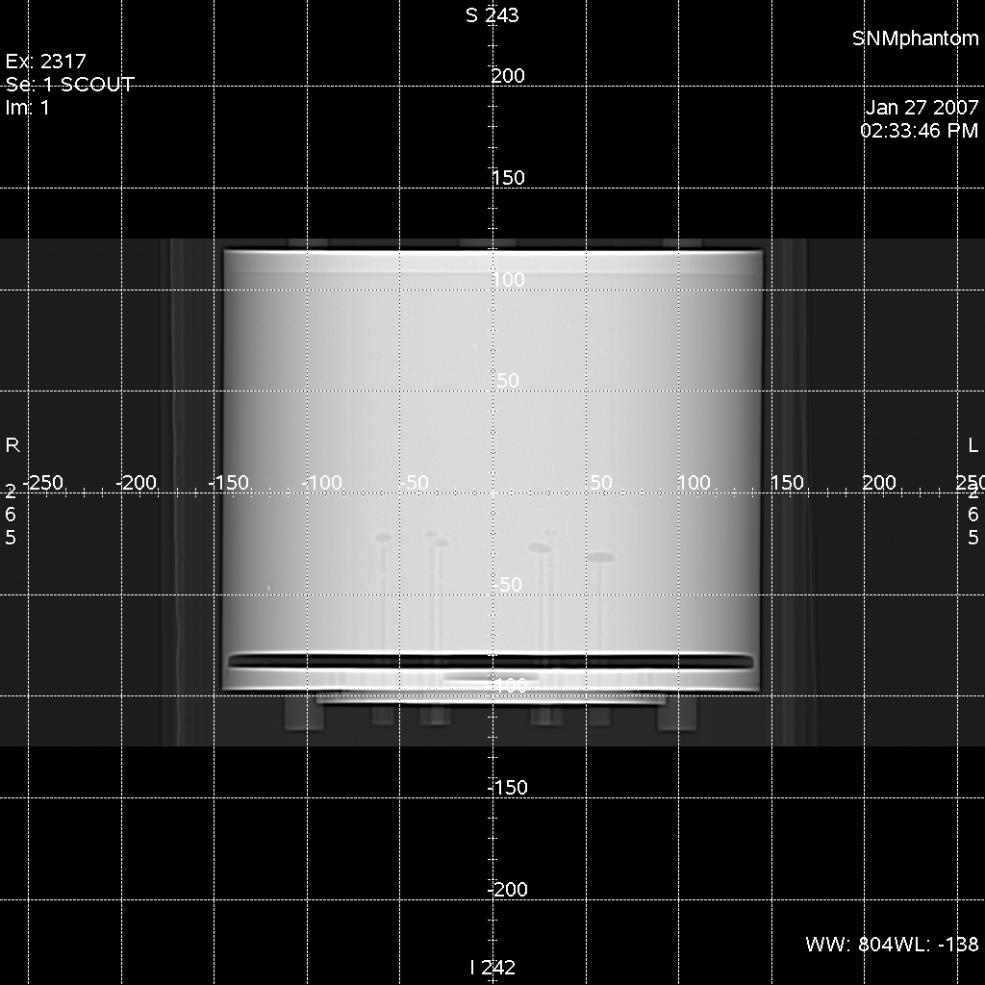
Figure 2: Scout (projection) views of aligned phantom on scanner couch.

4. CT Parameters

Due to the thickness of the phantom, images resulting from standard clinical acquisition and reconstruction parameters were deemed too noisy. Thus every effort was made to suppress image noise. The axial field of view (AFOV) for the CT scan was chosen to match or exceed the axial extent of the PET axial field of view (for one PET bed position) and centered to allow for attenuation correction of the PET scans.

Table 3: CT parameters

5. PET Parameters

Data for the SNM Germanium Phantom were acquired using a GE Discovery STE-16 PET/CT scanner (16-row MDCT). The scan was acquired using a 3D (no septa) mode in a 5-minute acquisition. The reconstruction was done using the 3D reprojection algorithm of Kinahan and Rogers. Maximum and average activity concentrations (kBq/mL) were estimated using the techniques as described below. The resulting activity concentrations were also converted into target-to-background (T/B) ratios, and SUVs.

Table 4: PET parameters

Detailed PET Reconstruction Parameters

The PET scans for each of the 20 patients was reconstructed using 3D Kinahan-Rogers reprojection and Filtered back projection reconstruction method. The PET images were acquired in a single-bed-coverage, limiting the axial field-of-view to 15.3 cm. The number of reconstructed images was 47, each having a slice thickness of 3.27 mm, 128 x128 pixels, 350 mm FOV, with Hanning filtering equaling 10 mm, which is typically used clinically. The images were corrected for scatter, decay, attenuation and dead time, and randoms (from singles).

6. ROI Analyses for SNM Lesion Phantom Hot Spheres and Background

Three different ROI analysis methods were applied to the reconstructed hot sphere images. For all three methods we reported the maximum and the mean values for two or more slices. The maximum was calculated as the maximum (over all slices) of the maximum value for each slice. The mean was calculated as the mean (over all slices) of the area-weighted mean value for each slice. All ROI analyses were conducted on a GE AW workstation (not the GE DSTE-16 used to acquire and reconstruct the images).

Method 1: (Multiple slice CT ROIs): ROIs were drawn on interior sphere cross-sections on CT slices for all sphere cross-sections that were air-void free and copied to the corresponding PET slice. These selection criteria identified 2 slices for the 10 mm and 13 mm spheres, 4 slices for the 17 mm and 22 mm spheres, 6 slices for the 28 mm spheres, and 9 slices for the 37 mm spheres. Figure 3 shows typical CT ROI size and placement on PET images.

Method 2: (Two slice CT ROIs): Method 2 is the same as method 1 except only the two PET slices that corresponded to the two CT slices with largest sphere cross-sections were analyzed.

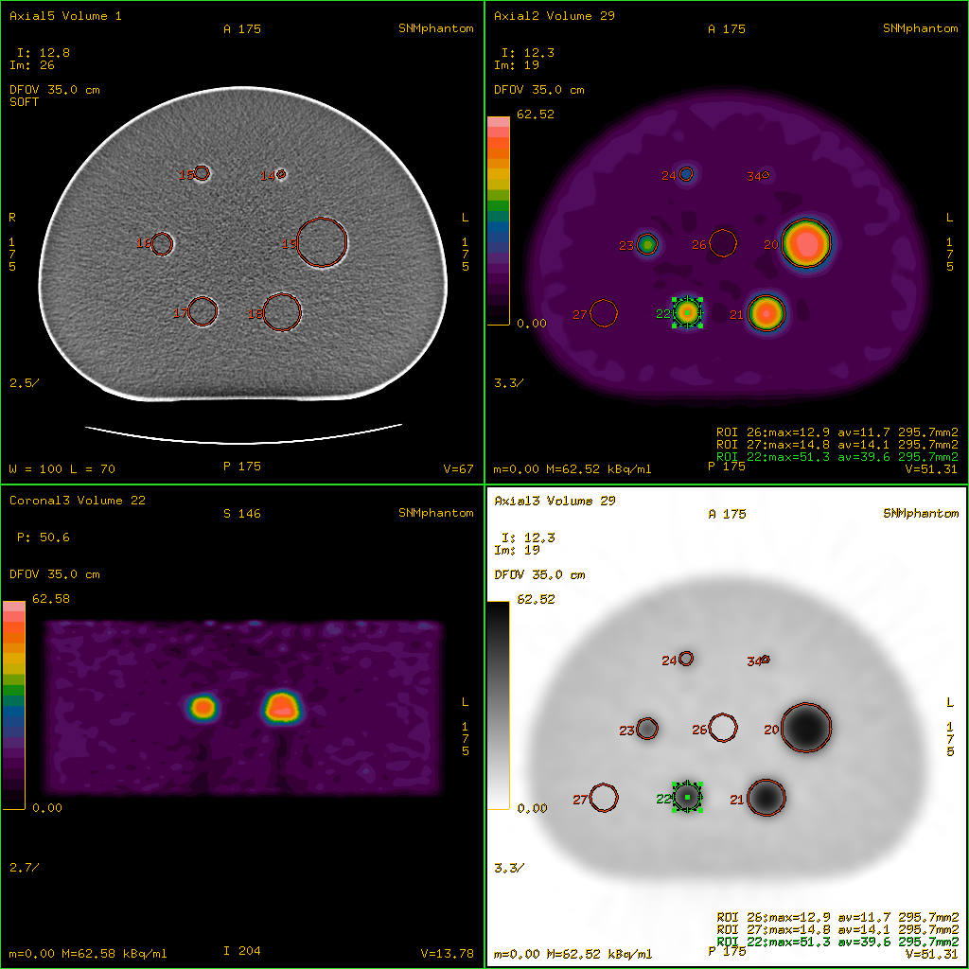

Figure 3: Typical CT ROI size and placement on PET images

Method 3: (Two slice, peak 1 cm diameter ROI): Method 3 is the same as method 2 except a constant 1 cm diameter (ROI area = 0.796 cm² or effective diameter of 1.01 cm with 10.6 pixels in ROI) circular ROI was drawn on every sphere with the requirements that the ROI contain the maximum pixel value for the sphere in that slice. Then small manual adjustments to the transverse ROI location were used to maximize average activity. Figure 4 shows typical 1 cm sphere ROI placement.

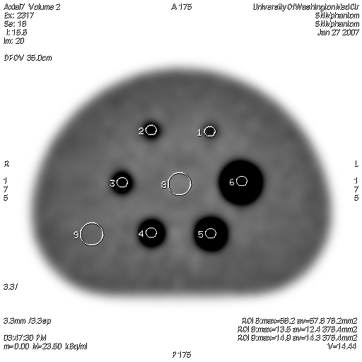
Figure 4: Typical 1-cm sphere and 2.2 cm background ROI placement

Background maximum and average volumetric activity concentrations (kBq/mL) were determined using a 2.2 cm diameter circular ROI placed in the phantom center as illustrated by ROI #8 in Figure 4 and a 2. 2 cm diameter ROI centered at the intersection of lines bisecting the centers of the 22mm and 28mm spheres and the centers of the 13mm and 17mm spheres as shown by ROI #9 in Figure 4. Center and outside background ROIs were drawn on the nine PET slices that were used for Method 1 sphere ROI analysis. The maximum and average volumetric activity concentrations from the resulting 18 background ROIs were averaged to determine maximum and average background activity concentrations for each reconstruction.

The resulting volumetric activity concentrations were converted into target-to-background (T/B) ratios, and weight-based SUVs using an estimated epoxy weight of 24 lbs. All of these results were plotted versus sphere diameter and processing method. Calculated average background SUVs and a comparison of average measured background volumetric activities is shown for the 30 minute scans in Table 5. Selected plots of recovery coefficient versus sphere diameter and acquisition / reconstruction method are shown in Figure 4.

Table 5: Average background values for 30 min scan:
 | Calculated | Measured | True | Diff (M-T)/T
 | SUV (g/mL)  (± SD) | (kBq/ml)  (± SD) | (kBq/ml)  (±10%) | (%)
2D FBP | 1.01 ± 0.05 | 14.9 ± 0.7 | 16.0 | -7%
3D 3DRP | 0.91 ± 0.06 | 13.4 ± 0.9 | 16.0 | -16%
2D OSEM | 1.04 ± 0.05 | 15.3 ± 0.8 | 16.0 | -4%
3D OSEM | 0.90 ± 0.07 | 13.3 ± 1.0 | 16.0 | -17%

Figure 4. Selected results for overall scale factors.

Table 6: Average sphere and background (BG) ROI conc. for 30 min 3D FBP scan:
 | Measured | True |  |  | Diff (M-T)/T | 37mm Sphere
 | (kBq/ml)  (± SD) | (kBq/ml)  (±10%) |  |  | (%) | T / BG  (unitless)
37mm dia sphere | 47.3 ± 0.6 |  | 64.7 | -18.9% |  |  | n/a
Center BG (n=9) | 12.6 ± 0.7 |  | 16.3 | -13.7%
Outside BG (n=9) | 14.1 ± 0.4 |  | 16.3 | -3.4%
Combined BG (n=18) | 13.4 ± 0.9 |  | 16.3 | -8.2%

7. Flood Phantom Measurement and Results

As part of the proposed test a uniform cylinder is filled with either FDG or F-18 flouride in water to test the procedures used with dose calibrators and SUV definition. During scan setup the phantom was registered in the scanner registration software with the parameters listed in Table 6 (unlisted parameters were left blank). The CT and PET parameters for the flood phantom were the same as for SNM lesion phantom as previously discussed in sections 4 and 5.

Table 6: Flood phantom exam parameters
Last name: | SNMphantom
Weight: | 14.4 lbs (= 6.53 kg)
Height:
Pre-injection assay (mCi or MBq): | 2.2 mCi
Date and Time of pre-injection assay: | 02/12/2007 @ 12:15:30 pm
Date and Time of Injection: | 02/12/2007 @ 12:18:30 pm
Post-injection assay (mCi or MBq): | 0.0
Date and Time of post-injection assay: | 02/12/2007 @ 12:19:30 pm

Average volumetric activity concentrations were measured on 20 adjacent PET slices using a constant 7 cm diameter (ROI area = 150 cm² or effective diameter of 13.8 cm with 2011 pixels in ROI) circular ROI on a GE AW workstation. Typical ROI size and placement is displayed in Figure 5. The resulting averages of the measured volumetric activity and averages of calculated weight-based SUVs are shown below in Table 7.

Table 7: Average uniform FDG flood phantom results for 7 min scan (n=20):
 | Measured | Calculated SUV | True SUV |  | Diff (C-T)/T
 | (kBq/ml)  (± SD) | (unitless)  (± SD) | (unitless)  (± SD) |  | (%)
2D FBP | 10.3 ± 0.1 | 1.02 ± 0.01 |  | 1.00 | 2.0%
3D 3DRP | 9.9 ± 0.1 | 0.98 ± 0.01 |  | 1.00 | -2.0%
2D OSEM | 10.4 ± 0.1 | 1.04 ± 0.01 |  | 1.00 | 4.0%
3D OSEM | 9.8 ± 0.1 | 0.97 ± 0.01 |  | 1.00 | -3.0%
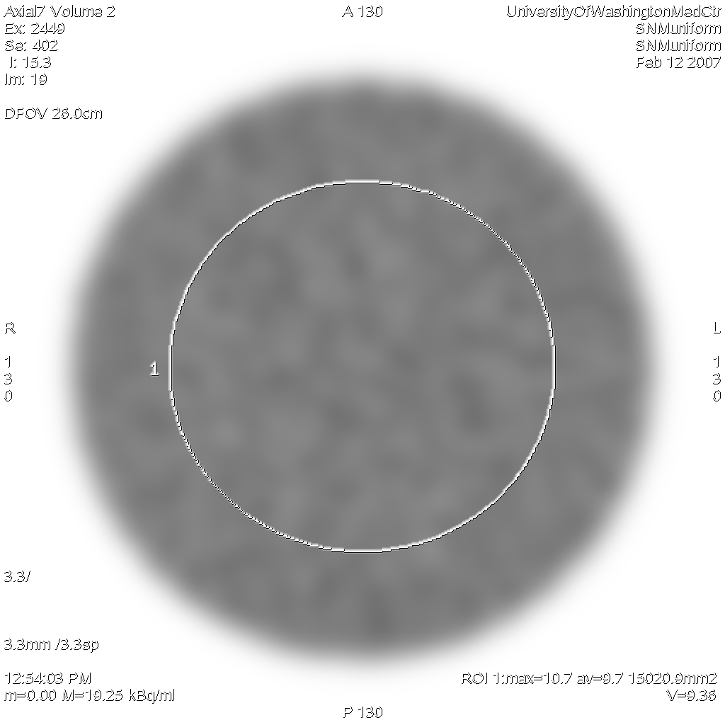
Figure 5: Typical Flood Phantom ROI size and placement

